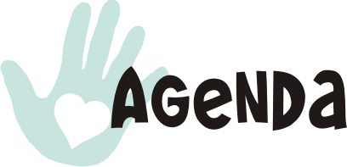  7:30 a.m.  Registration  8:00 a.m. to 9:00 a.m.  Creating the Tone for Healing & Wellness through the use of  Tibetan Bowls & Aromatherapy  Presented by Rosalind O’Neil, CTRS, ACC  9:15 a.m. to 10:15 a.m.  Using Recreation Therapy to Build Community Programs for Clients, Volunteers and Families  Presented by Leanne Murrillo, CTRS  and April Reed, LMSW  10:30 a.m. to 11:30 a.m.  Understanding Birth Order to Enhance Recreation Therapy Programs  Presented by KJ Sloan, LCSW  11:30 a.m. to 12:45 p.m.  Lunch & Annual Membership Meeting  1:00 p.m. to 1:30 p.m.  Legislative Update  1:45 p.m. to 2:45 p.m.  Incorporating Family into Community Recreation Therapy Programs  Presented by Kelsey Bocken, CTRS,  Kayla Uptain, CTRS, and Katie Ritter, CTRS  3:00 p.m. to 4:00 p.m.  Integrating Family into Mental Health Recreation Therapy Intervention Programs  Presented by Suzanne Prosser, CTRS  4:15 p.m. to 5:15 p.m.  Improved Wellness for Individuals with Physical Disability through Recreation Therapy  Presented by Leanne Murrillo, CTRS  5:30 p.m.  ASTRA Social at Local Restaurant! |  | 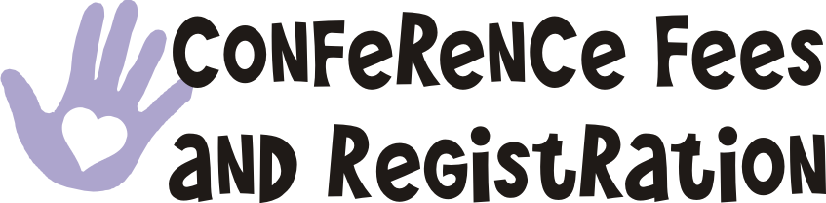  Pre-registration may be completed via the ASTRA website (astra-tr.com) using a credit card or pay pal. You must first register as a member on the website.  CEU pre-approval is in process.  ATRA and NCTRC cannot guarantee that every session offered for this continuing education opportunity will be granted CEUs.  For questions regarding  on-line registration contact  Jessica Voss, Membership Chair  jlvoss1@asu.edu  Registration may also be completed the day of conference using check, money order or cash.    Contact Johanna Avilez, Conference Chair  javilez2005@yahoo.com |  | 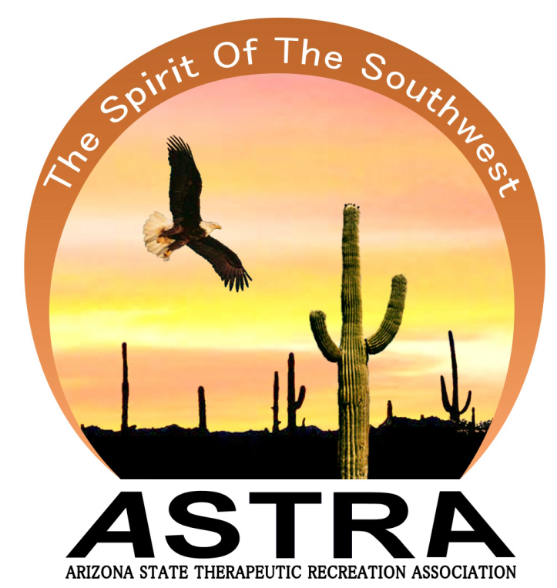  Invites you  to attend  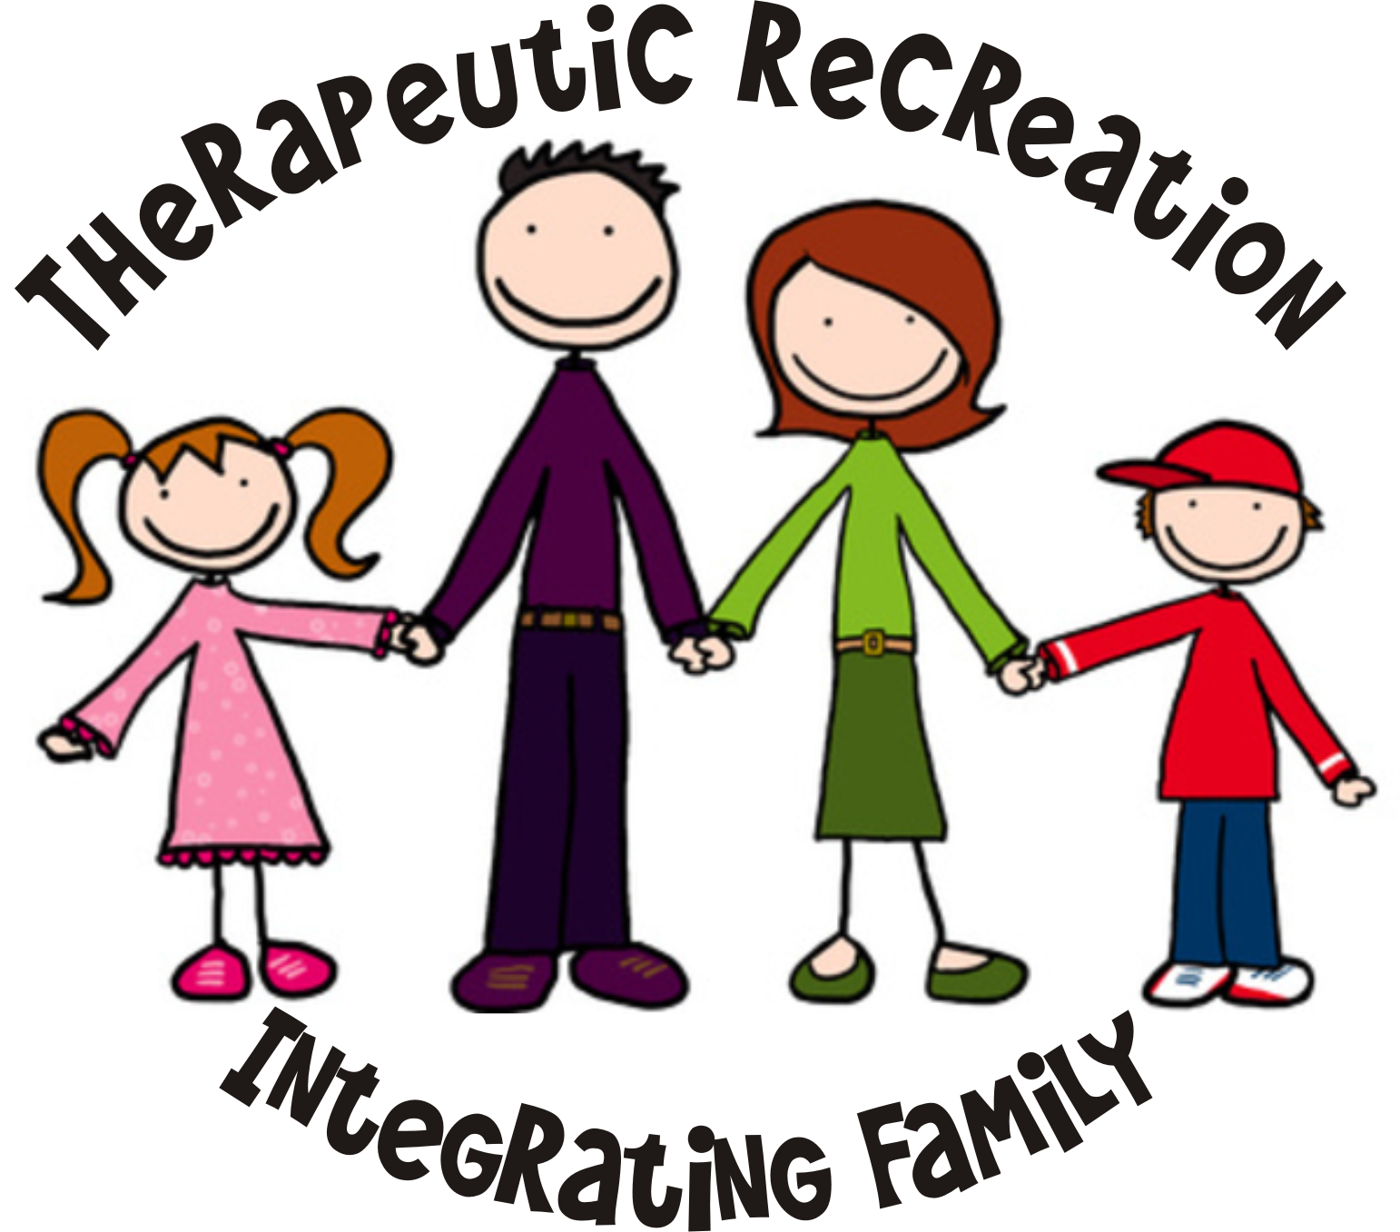  Friday, May 1, 2015  Disability Empowerment Center  5025 East Washington Street  Phoenix, Arizona
  $ 90.00 | Full day conference fee for ASTRA Members
  110.00 | Full day conference fee for Non-ASTRA Members
  20.00 | ASTRA Annual Membership
  25.00 | ASTRA Board Member
  25.00 | TR Student Fees. (Full day conference and ASTRA Membership)
  10.00 | CEU Fee to be pre-paid or paid the day of conference
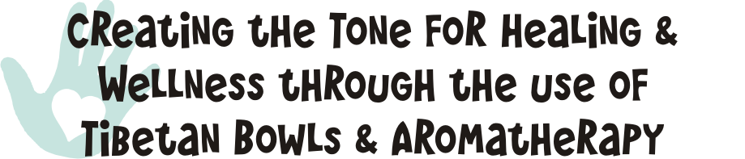  (0.1 CEU)  Presented by Rosalind O’Neil, CTRS, ACC  Learning Outcomes:  - Identify three therapeutic benefits of this modality, while exploring the history, purpose, and practice of Tibetan Singing Bowls and Aromatherapy.  - Identify three responses observed to the therapeutic interventions presented on a small group of individuals and be able to discuss possible responses from utilizing these interventions.  - Identify three ways recreation therapists can implement these interventions in their facilities successfully.  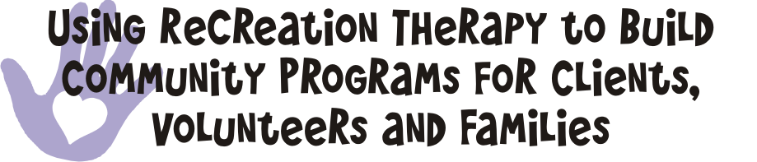  (0.1 CEU)  Presented by Leanne Murrillo, CTRS and April Reed, LMSW  Learning Outcomes:  - Identify three ways recreation therapists can encourage client, volunteer and family choice involvement within programming options.  - Identify three examples of programs that coordinate client and family participation at ABIL.  - Identify three specific ways in which client/family participation increases clients’ independent living skills. |  | 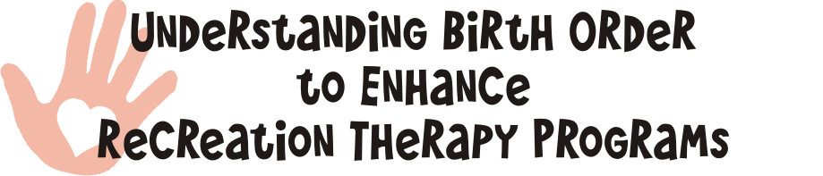  (0.1 CEU)  Presented by KJ Sloan, LCSW  Learning Outcomes:  - Identify the theoretical underpinnings of Adlerian Psychology.  - Identify Adler’s Birth Order Analysis and three examples of how it applies to Recreation Therapy programming.  - Identify three examples of how Adler’s Research can be incorporated into practice by Recreation Therapists.    (0.1 CEU)  Presented by Kelsey Bocken, CTRS, Kayla Uptain, CTRS, and Katie Ritter, CTRS  Learning Outcomes:  - Identify three ways incorporating family into client programming can increase overall participation in recreation therapy and general recreation programs.  - Identify three positive client outcomes when including family into a client’s treatment program.  - Identify three strategies for incorporating family interventions into a Recreation Therapy services program. |  |   (0.1 CEU)  Presented by Suzanne Prosser, CTRS  Learning Outcomes:  - Identify four typical symptoms or characteristics of individuals with mental illness who may participate in recreation therapy programs  - Identify at least four creative facilitation techniques to implement when working with individuals with mental illness  - Identify at least one current recreation therapy program which could be adapted to incorporate family involvement and participation  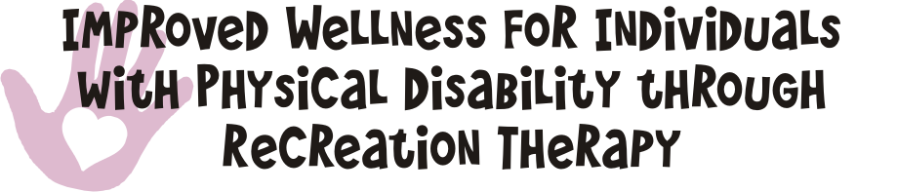  (.1 CEU)  Presented by Leanne Murrillo, CTRS  Learning Outcomes:  - Identify three goals of the Living Well program for individuals with physical disabilities.  - Identify three reasons client/family involvement improves client’s health and capacity to participate in chosen activities.  - Identify three ways program participation reduces depression and improves client outlook.  - Identify three benefits of incorporating family and client participation in general wellness and education programs provided by recreation therapists.

